**DEPARTMENT OF MECHANICAL ENGINEERING  
  
Subject: Fundamentals of Programming  
Lab Task. 7  
Submitted by: Muhammad Maaz  
Registration number: 479510  
Semester No. 1  
Date: November 16, 2023**

**FIRST PROGRAM**

#include <iostream>

using namespace std;

int main() {

int arr[10];

for (int i = 0; i < 10; i++) {

cout << "Enter an integer # "<<(i+1)<<":";

cin >> arr[i];

}

cout << "The array of integers is: "<<endl;

for (int i = 0; i < 10; i++) {

cout << arr[i] <<" ";

}

return 0;

}

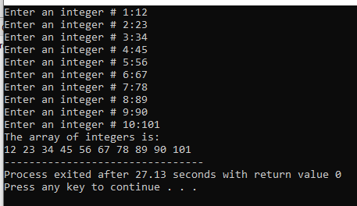

**Second Task**

#include <iostream>

using namespace std;

int main() {

int arr[5];

int sum = 0;

int product = 1;

for (int i = 0; i < 5; i++) {

cout << "Enter integer # " << i + 1 << ": ";

cin >> arr[i];

}

for (int i = 0; i < 5; i++) {

sum += arr[i];

product *= arr[i];

}

cout << "The sum of the array integers is: " << sum << endl;

cout << "The product of the array integers is: " << product << endl;

return 0;

}

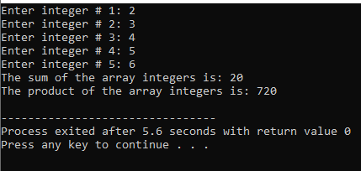

**Third Task**

#include <iostream>

using namespace std;

int main()

{

int daSize;

cout<<"Enter the size of diamond : ";

cin>>daSize;

if (daSize%2==0) {

cout<<"Please enter an odd number";

return 0;

}

char arr[daSize];

for (int i = 1; i<=daSize; i+=2) {

for (int j = 0; j<daSize; j++)

arr[j] = ' ';

int pos = (daSize-i)/2;

for (int j = pos; j<pos+i; j++)

arr[j] = '*';

for (int j = 0; j<daSize; j++)

cout<<arr[j];

cout<<endl;

}

for (int i = daSize-2; i>=1; i-=2) {

for (int j = 0; j<daSize; j++)

arr[j] = ' ';

int pos = (daSize-i)/2;

for (int j = pos; j<pos+i; j++)

arr[j] = '*';

for (int j = 0; j<daSize; j++)

cout<<arr[j];

cout<<endl;

}

return 0;

}  
